Задания для дистанционного обучения по английскому языку на
21.05.2020 г.
____________________________________________________________
Преподаватель: Бондарева Е.А.
Почта: elen.bondarevva@yandex.ru
__________________________________________________________________
Здравствуйте, уважаемые обучающиеся, как Вы знаете на время сложной эпидемиологической обстановки, наш техникум перешел на дистанционное обучение, в связи с этим отправляю Вам задания для самостоятельного изучения.
Порядок выполнения:
- Задания выполняются в рабочей тетради обучающегося.
- На период дистанционного обучения выполненную работу
необходимо отправить на электронную почту: Elen.bondarevva@yandex.ru
- В теме письма необходимо указать ФИО и № группы.
Онлайн словари:
https://www.lingvolive.com/ru-ru
https://dictionary.cambridge.org/

Практическое занятие №73 по теме:
Олимпийские игры
Цель: развитие навыков диалогической речи по теме «Спорт», изучение лексических единицы по теме.
Задание № 1. Прочитайте и переведите текст.
The Olympic Games.
The first record of the games dates from 776 BC in Greece. The important sports in the original Olympic Games were running, jumping, wrestling, throwing the discus and throwing the javelin. Only men competed, and they wore no clothes in order to have greater freedom of movement.
The first modern Olympiad took place in Athens in 1896. Since then the Olympic Games have been held every four years with only two exceptions because of the two world wars. There may be Summer and Winter Games.
In modern times the Olympic movement has become an enormous and expensive organization. The Winter Olympic Games are a multi-sport event held every four years.
The Winter Olympic Games have been hosted on three continents, but never in a country in the southern hemisphere. The United States has been the host three times. Austria, Canada, Italy, Japan, Norway and Switzerland have hosted the Games twice.
In 2014 Sochi was the first Russian city to host the Winter Olympics. Our Government, Olympic Sports Committee and sportsmen were preparing for this event with great enthusiasm. Our sportsmen won the greatest number of golden medals. We all supported our sportsmen. Our country is very proud of them.
Задание № 2. Определите, верны ли данные высказывания? Исправьте ошибочные, используя информацию в тексте.
- The first Olympic Games were held in Ancient Greece.
- Both men and women took part in the Games at that time.
- The men wore no clothes because of the hot weather.
- The Olympic Games have been held every four years since 776 BC.
- The programme of the modem Olympic Games consists of running, jumping,
wrestling, throwing the discus and throwing the javelin.
- The Olympic Games are held every four years. There were only two exceptions because of earthquakes.
- The Winter Olympics have been hosted in various countries on three continents.
- The USA and France have hosted the Games several times.
- Sochi was the first Russian city to host the Winter Olympics.
- The Winter Olympics have never been held in Russia before.
Пример: The first Olympic Games were held in Ancient Greece. True.
Задание № 3. Используя слова в рамке, дополните текст.
athletes, Zeus, circles, competitors, motto

Some Facts about the Olympic Games.
1. The five Olympic …… represent the five continents: Africa, North and South America, Asia and Australia. They are connected to symbolize the sports friendship amongst all the people in the world.
2. The Olympic …… "citius, altius, fortius" means "faster, higher, stronger" in Latin.
3. The first official Olympic Games took place in 776 BC. They were held in the honor of …, the supreme god of the Greeks.
4. The games are meant to promote respect amongst all the …, regardless of their race, religion or sex.
5. To get an idea of the number of competitors participating at the Olympic Games - at Sydney 2000, 10,300 ….. involved in 28 sports, 292 events and 635 matches.
Пример: The five Olympic circles represent the five continents: Africa, North and South America, Asia and Australia. They are connected to symbolize the sports friendship amongst all the people in the world.
Практическое занятие №74 по теме:
Популярные виды спорта Великобритании
Цель: закрепление лексических единиц по изученным темам, формирование навыка использования новых лексических единиц в собственных высказываниях по теме.
Задание № 1. Фонетическая зарядка.
[t], [d], [b].
[t]- get, time, take.
[d]- dog, date, dream.
[b]- been, bird, big.
Задание № 2. Изучите новую лексику занятия.
boxing [‘bɔksɪŋ] – бокс
discus throwing [‘dɪskʌs Ɵrounɪŋ] – метание диска
fencing [‘fensɪŋ] – фехтование
football [fʊ tbɔ:l] – футбол
hiking [‘haɪkɪŋ] – пеший туризм
hockey [‘hɔkɪ] - хоккей
horse-racing [hɔ:s’reɪsɪŋ] – скачки, бега
jogging [‘dʒ ɔg ɪ ŋ] – бег трусцой
rugby [‘rʌgbɪ] – регби
shooting [‘ʃu:tɪŋ] – стрельба
sprint [‘sprɪnt] –спринт, бег на короткую дистанцию
tennis [tennɪs] –теннис
volley-ball [v ɔl ɪb ɔ:l] - волейбол
water-polo [‘w ɔ:t ə’p oʊloʊ] – водное поло
wind-surfing [w ɪnd ‘sɜ:f ɪ ŋ] - виндсерфинг
wrestling [resl ɪ ŋ] – борьба
Задание № 3. В каждом предложении пропущено название вида спорта, дополните предложение по смыслу.
Карточка с заданием:
1. ____________ is practiced with a gun (винтовка).
2. ____________ matches are watched by thousands of people. My son can run with a
ball from morning till night.
3. In ____________ the opponent (соперник) must be thrown (бросать) to the ground.
4. A heavy round metal_________ is thrown by athletes.
5. __________ is done in the country for pleasure and exercise by those who like to be in
the open air.
6. In ___________ an oval ball is used by players.
7. ___________ is fought (сражаться) with swords (рапира, шпага).

8. ___________ is often won (выиграть, победить) in the Olympics by black
competitors (соревнующиеся), they are quicker.
9. ____________ is enjoyed on the waves (волна) in the sea.
10. In ___________ the sportsman must not be hit (ударить) below the belt (пояс).
11. ____________ is like mostly (главным образом) by elder (пожилой) people who
cannot run quickly.
12. _____________ is played by two teams with five sportsmen in each. Of course a ball
is needed.
13. _____________ is played by swimmers and also with a ball.
14. _____________ is betted on (делать ставки) by people who want to win a lot of
money.
15. _____________ is played by two or four people with a small ball.
16. _____________ is played on ice

Опорные картинки:
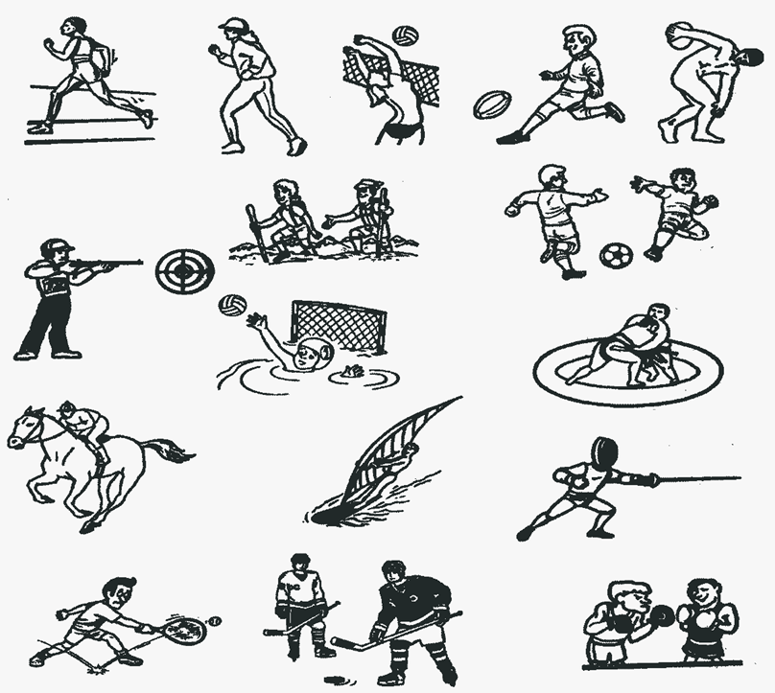
Ключевые слова:
boxing, discus throwing, fencing, football, hiking, hockey, horse racing, jogging, rugby, shooting, sprint, tennis, volley-ball, water-polo, wind-surfing, wrestling.
Пример: Shooting is practiced with a gun (винтовка).
В каждом предложении пропущено название какого-нибудь вида спорта. По смыслу можно догадаться, какого именно.
Дополнительный материал:
- Top Ten Most Popular Sports in UK https://www.youtube.com/watch?v=GhyPlflI29U

_____________________________________________________________________________
Homework

Задание № 1. Составьте сообщение по теме: "Спорт в Великобритании".

Практическое занятие № 75 по теме:
Монолог «Мой любимый вид спорта»
Цель: обобщение и систематизация знаний по теме «Спорт», развитие навыков монологической речи.
Задание № 1. Фонетическая разминка:
[l] play, ball, volleyball, basketball
[t ] football, tennis table, tennis, sport, skating
[r] cricket, running, rugby
[w] swimming, windsurfing, weightlifting
Задание № 2. Определите, о каком виде спорта (спортивном предмете) говорится в каждом из высказываний.
Пример: This game is played by two teams. There are six players in each team. They play game on an ice field. – Hockey.
- It is a team game. Two teams hit a large ball with their hands over a high
net. The ball is not allowed to bounce on the ground.
- It is a game of two players. Each player starts with sixteen different playing
pieces. They move the playing pieces on a board. The aim of the game is taking your opponent's king.
- Going deep under water.
- Jumping from a plane with a parachute.
- Riding skateboards, jumping and doing different tricks on them.
- Riding bikes on dangerous rocky or mountain roads or not on any road at all.
- Travelling on a raft down dangerous mountain rivers and waterfalls.
- Riding surfboards on waves.
- A pair of boots with metal blades on the bottom for moving quickly on an
ice.
- A strong hard hat that soldiers, motorcycle riders, the police wear to protect
their heads.
Слова-подсказки: volleyball, skydiving, surfing, a helmet, skates, diving, skateboarding, chess, mountain biking, rafting.
Задание № 3. Прочитайте диалог. Составьте свой, используя данный пример.
Dan: Do you like sports?
Bob: Yes, I do.
Dan: What sports do you go in for?
Bob: I go in for hockey in winter and football in summer. And what about you?
Dan: I like skating in winter and volleyball and tennis in summer.
Bob: Can you play tennis well?
Dan: Yes, I can. And what sport game can you play well?
Bob: I think I can play hockey well. I want to be a sportsman.
Dan: Oh, that’s fine.

